SQL Assignment – 14
D2_83822_Rohit
Entering, Deleting, and Changing Field Values.
1) Write a command that puts the following values, in their given order, into the salespeople table:
city – San Jose, name – Blanco, comm – NULL, cnum – 1100.

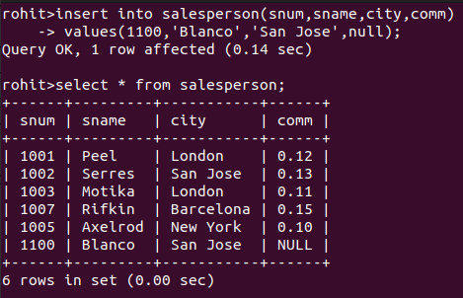

2) Write a command that removes all orders from customer Clemens from the Orders table.

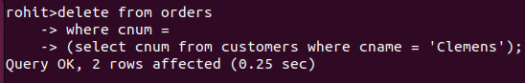

3) Write a command that increases the rating of all customers in Rome by 100.
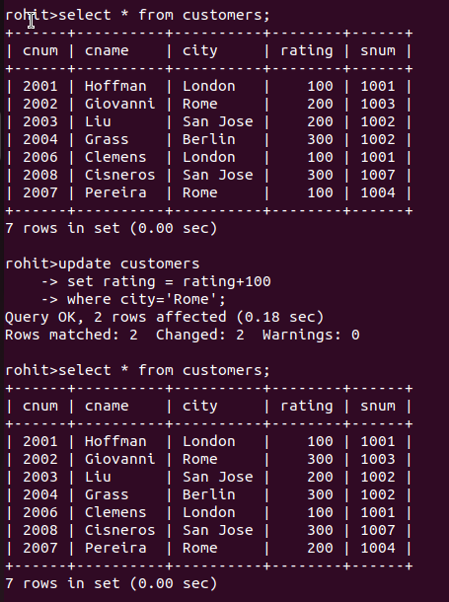

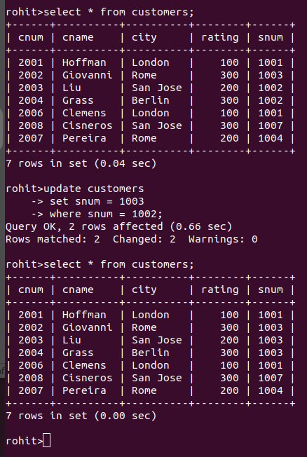
4) Salesperson Serres has left the company.Assign her customers to Motika.

